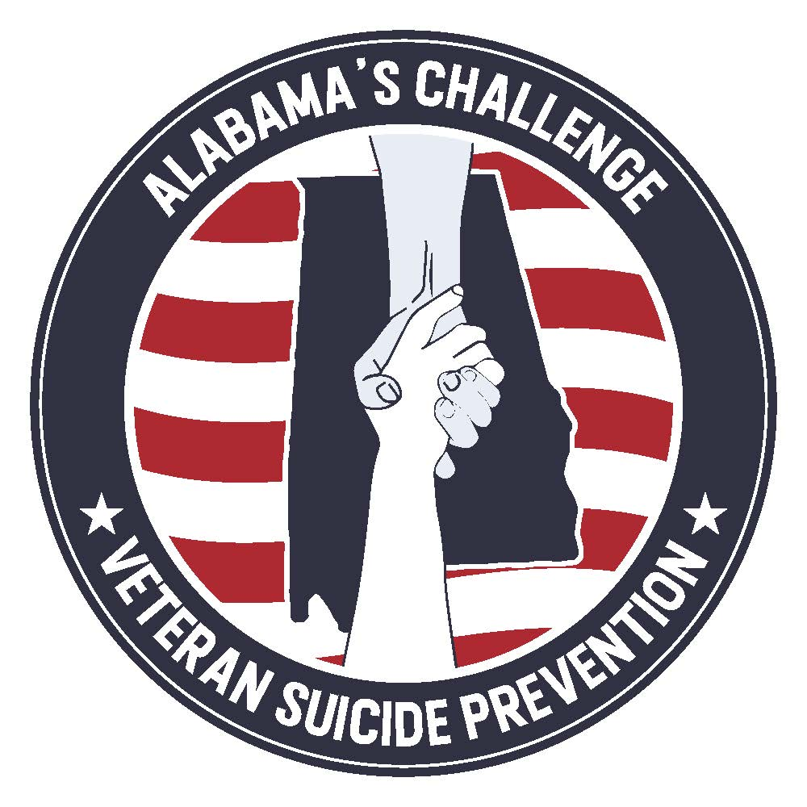

Service Members, Veterans, and their Families (SMVF) are at significantly higher risk for suicide than their civilian counterparts. Their service in defense of our nation and our state takes a toll which some find difficult to bear. Alabama’s Challenge was established to address the needs of this community who are at risk for suicide. The seal was crafted to reflect the nature of both the effort and those it aims to serve.

In recognition of their service and sacrifice, the colors are patriotic though muted to reflect the gravity of the issue. The imagery of the hands depicts that assistance is within reach for those who seek it. One hand is above the other because this initiative provides a hand up, not a hand out. The silhouette of Alabama is placed in the middle of the seal to recognize that this is a statewide effort to assist Alabama SMVF. And finally, the seal is round to emulate a challenge coin, a symbol the military community is familiar with and which has been used historically to recognize the contributions of individuals and membership within its ranks.

Alabama SMVF face unique challenges and have earned this special consideration. The seal itself represents Alabama’s commitment to serving the men and women who have bravely served our state and nation in uniform and the families that support them.

